**INCOME AND EXPENDITURE**

The multiplier: an informal Introduction  
Since households and firms are mutually interdependent, booms and busts involve chain reactions.

The multiplier helps us understand the extent of the chain reactions.

Basically, we want to understand how much extra income and spending are created from an initial change in spending.

The MPC (Marginal Propensity to Consume)  
Four simplifying assumptions:

* Producers are willing to supply additional output at a fixed price. As a result, changes in aggregate spending translate into changes in aggregate output, as measured by real GDP.
* We take interest rate as given.
* We assume that there is no government spending and no taxes.
* We assume that exports and imports are zero.

Given these simplifying assumptions, consider what happens if there is a change in investment spending.

Suppose that home builders decide to spend an extra $100 billion on home construction over the next year. The direct effect of this increase in investment spending will be to increase income and the value of aggregate output by the same amount: each dollar spent on home construction translates into a dollar’s worth of income for construction workers, suppliers of building materials, electricians etc. If the process stopped here, the increase in housing investment spending would raise overall income by exactly $100 billion. But the process does not stop there. The increase in aggregate output leads to an increase in disposable income that flows to households in the form of profits and wages. The increase in household’s disposable income leads to a rise in consumer spending, which, in turn, induces firms to increase output yet again. This means that there are multiple rounds of increases in aggregate output.

How large is the total effect on aggregate output if we sum the effect from all these rounds of spending increases?

A lot depends on how much consumers spend when they receive more income, so on **marginal propensity to consume** (**MPC**)

$MPC=\frac{Δconsumer spending}{Δdisposable income}$

e.g. if consumer spending goes up by $6 and disposable income goes up by $10, MPC = $6/10 = 0.6

Whatever is not spent is saved, so:

Marginal propensity to save, or MPS = the fraction of an additional dollar of disposable income that is saved.

**MPS = 1 - MPC**

The Multiplier Effect  
It estimate of what is the reaction from an exogenous introduction on money in the economy.  
Each $1 increase in aggregate spending raises both real GDP and disposable income by $1—and causes people to spend money. How much?

If investment spending rises by $100 billion, this will lead to a second-round increase of MPC × $100 billion. It is followed by a third-round increase in consumer spending of MPC × MPC × $100 billion, and so on up to:

Total increase in real GDP = (1 + MPC + MPC2 + MPC3 + . . .) × $100 billion or total increase in real GDP from a $100 billion rise in I is equal to

$$\frac{1}{1-MPC}×\$$$

The same analysis can be applied to any other change in aggregate spending. If ΔAAS = autonomous change in aggregate spending and ΔY = change in real GDP

$ΔY =\frac{1×ΔAAS}{1-MPC}$

And the **Keynesian multiplier** is

$$\frac{ΔY}{ΔAAS}=\frac{1}{1-MPC}$$

When marginal propensity to consume is very high, the multiplier will be very large: thanks to the chain reaction, each dollar injected into the economy will increase GDP in the value obtained through the multiplier.

The multiplier: Why is it so important?  
It is used to analyze the effects of fiscal and monetary policies:

**Consumer Spending Investment Spending Income-Expenditure Model**

Consumer Spending

Households are constantly confronted with choices—not just about what to consume but also about how much to spend. And that depends mostly on income.

* **Current disposable income** is theincome after taxes are paid and government transfers are received.
* **Consumption function**is an equation showing how an individual household’s consumer spending varies with the household’s disposable income.

***Consumption Function  
c* = *a* + *MPC* × *yd***

Where

***c***= a household’s consumer spending (y axis)  
***yd***= household disposable income (x axis)  
***MPC***= marginal propensity to consume (slope of the consumption function)  
***a*** *=* a constant, autonomous consumer spending, what a family would spend even with zero income (vertical intercept of the consumption function)

* Since, MPC = Δc/Δyd
* Multiplying both sides of the equation by Δyd, we get**: MPC × Δyd = Δc**

In other words, when yd goes up by $1, c goes up by MPC × $1.

***Aggregate Consumption Function***

* A**ggregate consumption function** is thethe relationship for the economy as a whole between aggregate disposable income and aggregate consumer spending.

**C = A + MPC × YD** Same form as consumption function, just aggregate.

Shift in the Aggregate Consumption Function (ACF), two principal causes of shifts of the aggregate consumption function:

* **Changes in expected future disposable income**
* **Changes in aggregate wealth**

Investment Spending

**Small yet powerful:** Although much smaller than consumer spending, **investment spending tends to drive the booms and busts in the business cycle**

There is a difference between **planned** and **unplanned investment spending**.

**Planned investment spending**is the investment spending that businesses intend to undertake during a given period.It has three main determinants:

1. **The interest rate:** firms often do not use their own money to make an investment, yet they ask for a loan (borrow money) which is exactly the interest rate. Therefore, if loans are very high investments will be reduced because access to financial resources is difficult and, as a result, interest rates are very high. Therefore, interest rates are the cost of investment projects and there is a **negative relationship** between interest rate and investment. When interest rates are low, more loans are undertaken and investment rises (other things equal).

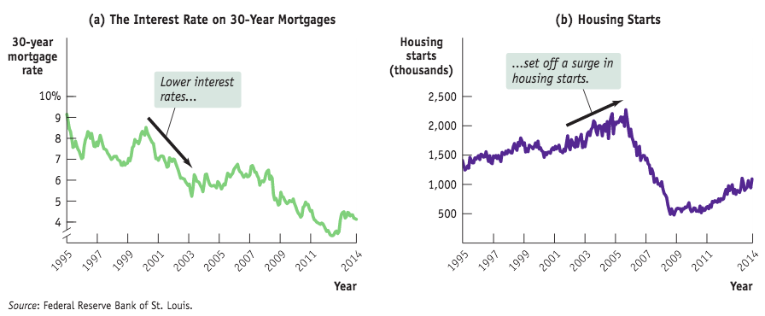

1. **Expected future real GDP:** real GDP is a proxy of a growth of sales, so there is a positive relationship between this expectation and investments. Other things equal, firms will undertake more investment spending when they expect their sales to grow and, other things equal, the current level of productive capacity has a negative effect on investment spending: other things equal, the higher the current capacity, the lower is investment spending. A good indicator of high expected growth of future sale is a high expected future growth rate of real GDP. A higher expected future growth rate of real GDP results in a higher level of planned investment spending. A lower expected future growth rate of real GDP leads to lower planned investment spending. This relationship is summarized by the **accelerator principle**: *a higher rate of growth in real GDP leads to higher planned investment spending and a lower growth rate of real GDP leads to lower planned investment spending.*
2. **Current level of production capacity**

But the actual investment spending is not always equal to the planned investment spending.

Inventories and Unplanned Investment Spending:

We need some concepts to understand this:

* **Inventories:** stocks of goods held to satisfy future sales.
* **Inventory investment:** the value of the change in total inventories held in the economy during a given period.
* **Unplanned inventory investment:** unplanned changes in inventories occurring when actual sales are more or less than businesses expected. If it is positive, the sales have been lower than expected and therefore the economy is slowing down (rising inventories). On the contrary, if it is negative sales have been more than expected, economy is growing and there will be a reduction in inventory investments because the business can use its existing stocks to satisfy future sales (falling inventories).
* **Actual investment spending:** the sum of planned investment spending and unplanned inventory investment.  
  So in any period **I = IUnplanned + IPlanned**

Unplanned Inventory Investments

Inventories play a central role in the economy, so economists pay attention to the changes in firms’ inventories when trying to understand the direction of the economy.

**Rising inventories** typically indicate 🡪 POSITIVE UNPLANNED INVENTORY INVESTMENT and a SLOWING ECONOMY, as sales are less than had been forecast

**Falling inventories** typically indicate 🡪 NEGATIVE UNPLANNED INVENTORY INVESTMENT and a GROWING ECONOMY, as sales are greater than forecast

The Income-Expenditure Model

The analysis of consumption function, planned and unplanned investments are necessary to understand the **income-expenditure** **model**, explaining the relationship between disposable income and total spending in an economy.   
To understand it, we have to make some assumptions:

* **Changes in overall spending** lead to **changes in aggregate output**: we assume that producers are willing to supply additional output at a fixed price level.   
  This also means that in this simplified model **nominal GDP = real GDP**.
* The **interest rate** is **fixed**, predetermined and unaffected by factors we analyze in the model.
* **Taxes**, **government transfers** and **government purchases** are all **zero**.
* **Exports** and **imports** are both **zero** (isolation from the rest of the world).

Planned Aggregate Spending and Real GDP

In this case, the total GDP is defined just as

**GDP = C + I 🡪 GDP = YD**

Since prices are fixed 🡪Nominal GDP = Real GDP 🡪 Real GDP = Disposable Income because of the absence of government intervention.  
Our aggregate consumption function is 🡪 **C = A + MPC × YD**

If we assume Iplanned is fixed, then 🡪 **AEPlanned = C + IPlanned**

Where **planned aggregate spending** isthe total amount of planned spending in the economy.

Income-Expenditure Equilibrium:

Planned aggregate spending can be different from real GDP only if there is unplanned inventory investment, I(Unplanned), in the economy.

If firms have **overestimated sales** and produced too much, there will be unintended additions to inventories (and IUnplanned will be positive).

If firms have **underestimated sales** and produced too little, there will be unintended drops in inventories (and I(Unplanned) will be negative).

__________________________________________________________________________

e.g. if C = 300 + 0.6 × YD, then

At the value of 2000, the economy is in equilibrium because the aggregate spending planned is equal to real GDP. The planned aggregate spending will be a straight line with the same slope as aggregate consumption function and different vertical intercept. For all production levels except one, real GDP is either more or less than AEPlanned.

__________________________________________________________________________

In reality, however, real GDP can be different from AEPlanned: it will be higher if there are negative unplanned inventory investments and vice versa.

GDP = C + I

= C + IPlanned + IUnplanned

= AEPlanned + Iunplanned

Whenever real GDP exceeds AEPlanned 🡪 IUnplanned is positive.   
Whenever real GDP is less than AEPlanned 🡪 IUnplanned is negative.

The economy is in the **income-expenditure equilibrium** when **aggregate output** (**real GDP**) is **equal** to **planned aggregate spending**. This equilibrium is recognized by the **Keynesian cross**, a diagram that identifies it as the point where a planned aggregate spending line crosses the 45-degree line. Income–expenditure equilibrium GDP is the level of real GDP at which real GDP equals planned aggregate spending.

The Multiplier Process and Inventory Adjustment

When planned spending does not equal output, it shows up in changes to inventories. This is why changes in inventories are considered a leading indicator of future economic activity.

To show the relationship between the Keynesian multiplier and the income-expenditure model, let’s consider the same example, namely the effect of an autonomous/exogenous increase in planned aggregate spending of $400 billion.

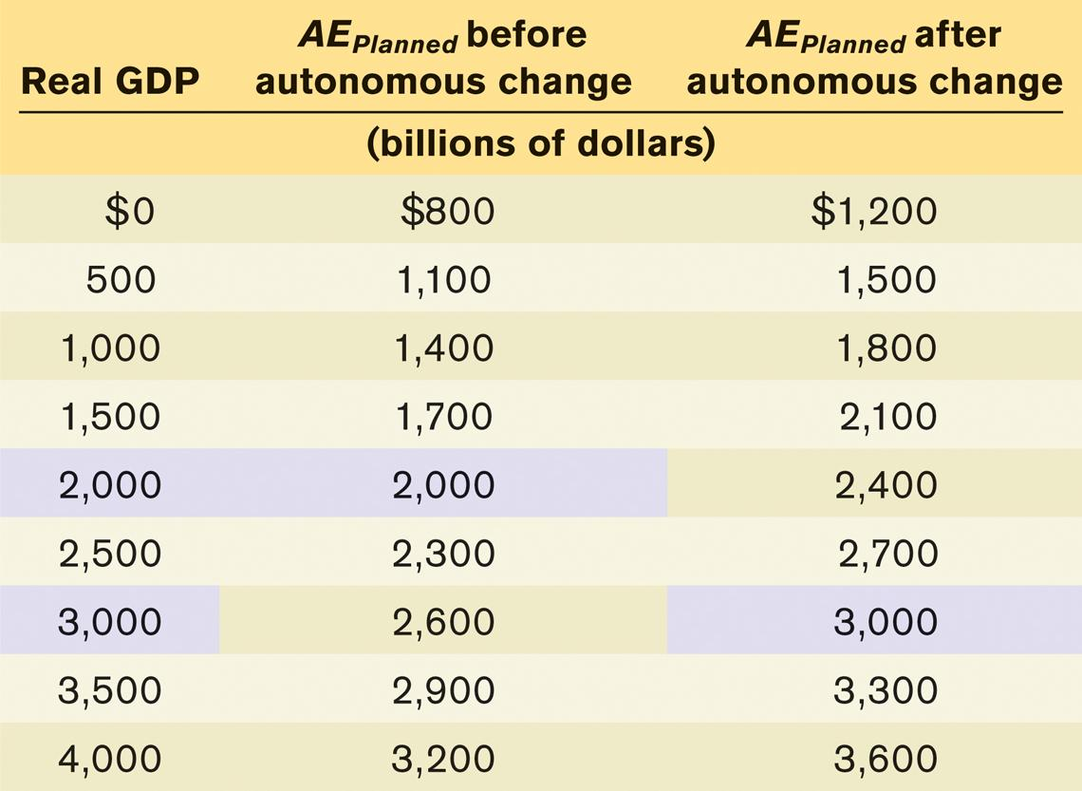The fact that the rise in equilibrium GDP, from $2,000 to $3,000, is much larger than the autonomous increase in aggregate spending, ($400) has a familiar explanation: the **multiplier process**. In fact, the exogenous change in aggregate spending is represented as a shift up of the aggregate spending line. At the initial equilibrium, the planned aggregate spending is greater than real GDP (negative unplanned inventory investments 🡪 reduced inventories because they are used to satisfy an increase in demand); then real GDP increases by $1000 because of the marginal propensity to consume (0.6), the multiplier (2.5) and the variation in aggregate spending ($ΔAAE=4000$).

The Paradox of Thrift

In macroeconomics, the outcome of many individual actions can generate a result that is different from the simple sum of those individual actions.

If your house loses value because the housing bubble has burst, you might adjust and spend less. If everyone else does the same, the economy is depressed, jobs are lost, and everyone is worse off because of their virtuous individual actions